LAYLA BERNAL  ENTREPRENEUR | BUSINESS DEVELOPMENT LEADER  COMMUNITY ADVOCATE | LIFELONG LEARNER  “Building businesses, empowering people, and creating meaningful impact through service, innovation, and responsible leadership.”  CURRENT LEADERSHIP & BUSINESS ROLES  - Partner & Director of Business Development and Client Relations — KZNX Consulting and Services  - Founder and Owner — EVE Events Qatar  - Founder and Owner — La Diva De Quafeir Beauty Centre  - Adviser — Overseas Filipino Investor and Entrepreneur Movement (OFIE-M), 2026  - Regional Coordinator, Middle East and Africa — ALSE of Life Alumni Association  - Vice President — ALSE of Life Alumni Association, Qatar  - Vice President — Grand Majestic Lady Eagle Club | 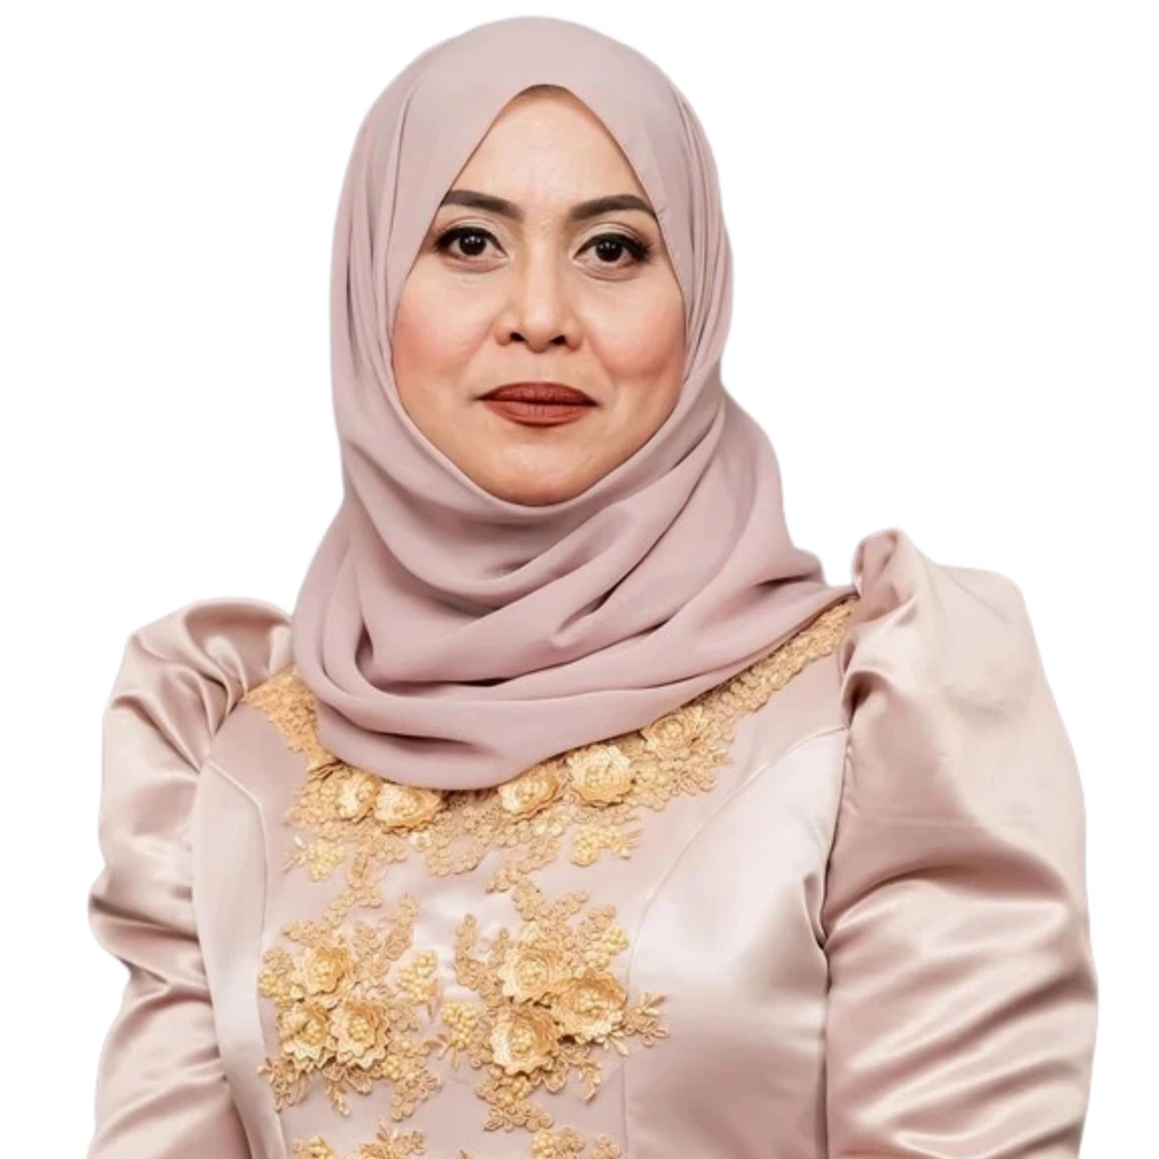  LOCATION  Doha, State of Qatar  CONTACT  +974 6661 1881  estrellaorzal@gmail.com  PROFILE  Filipino entrepreneur, business development leader, former OFW, and community advocate with extensive experience in business ownership, client relations, professional development, cross-cultural service, and values-based leadership.
PROFESSIONAL PROFILE • BUSINESS PORTFOLIO • LEADERSHIP • EDUCATION • RECOGNITIONS

EXECUTIVE PROFILE
A leadership journey shaped by resilience, enterprise, service, and continuous learning
Estrella Orzal Bernal, professionally known as Layla Bernal, is a Filipino entrepreneur, business development leader, community advocate, and former Overseas Filipino Worker based in Doha, Qatar. Her journey reflects more than two decades of personal and professional growth in a multicultural environment, where she transformed practical experience, determination, and community involvement into a portfolio of businesses and leadership responsibilities.
As the founder and owner of EVE Events Qatar and La Diva De Quafeir Beauty Centre, Layla has built service-oriented enterprises grounded in professionalism, creativity, quality, client trust, and long-term relationships. Her experience spans event management, beauty and wellness operations, brand development, customer experience, stakeholder coordination, business administration, and people management. She also serves as a Partner and Director of Business Development and Client Relations at KZNX Consulting and Services, where she contributes to strategic partnerships, training initiatives, client engagement, market development, and the delivery of practical, future-ready professional solutions.
Her leadership extends beyond business. Layla currently serves as Adviser of the Overseas Filipino Investor and Entrepreneur Movement (OFIE-M) in 2026, following her term as President in 2025. Through OFIE-M, she has supported programs in entrepreneurship, financial literacy, investment awareness, women’s empowerment, wellness, and community collaboration. She also serves as Regional Coordinator for the Middle East and Africa and as Vice President of the Qatar Alumni Association within ALSE of Life, helping connect, develop, and mobilize Filipino leaders across the region.
Layla’s professional identity is defined by a balanced approach: commercial discipline combined with social responsibility. She believes that business growth should create value not only for owners and clients, but also for employees, partners, families, and the wider community. Her leadership practice emphasizes integrity, service, accountability, cultural sensitivity, learning, innovation, and the responsible use of technology.
BUSINESS  Entrepreneurship, service operations, partnerships, customer experience, and sustainable growth. | LEADERSHIP  Values-based leadership, organizational development, stakeholder engagement, and community mobilization. | FUTURE-READY  Strategic management, AI-enabled learning, digital capability, and continuous professional development.

LEADERSHIP PHILOSOPHY
Layla views leadership as a responsibility to create direction, develop people, earn trust, and convert ideas into meaningful action. For her, influence is strongest when it is supported by competence, humility, consistency, and the willingness to serve. She aims to lead in a way that helps others become more confident, financially informed, professionally capable, and prepared for the future of work.
Leadership statement: “Success becomes more meaningful when it opens opportunities for others, strengthens the community, and leaves a positive legacy.”

BUSINESS PORTFOLIO & PROFESSIONAL EXPERIENCE
Entrepreneurial leadership across consulting, training, events, beauty, and client services
2026 – Present  Partner & Director of Business Development and Client Relations  KZNX Consulting and Services / KZNX Training Consultancy | Supports business growth through strategic relationship management, partnership development, market positioning, and client-centered service design.  Contributes to professional training and consulting initiatives in leadership, business improvement, organizational development, workplace capability, AI-enabled learning, and future-ready skills.  Represents the company in external engagements and helps translate client needs into practical programs, proposals, and long-term collaboration opportunities.

2013 – Present  Founder and Owner  EVE Events Qatar | Leads event planning, coordination, concept development, supplier management, talent and production support, photography, photobooth services, decoration, licensing coordination, and client relations.  Manages projects from initial consultation to execution, ensuring that creative concepts are supported by operational discipline, budget awareness, professionalism, and quality service.  Works with community organizations, private clients, corporate partners, and institutional stakeholders to deliver culturally relevant and well-coordinated events.

2010 – Present  Founder and Owner  La Diva De Quafeir Beauty Center | Directs a client-focused beauty and wellness business offering hair, nail, facial, waxing, skincare, and related personal care services.  Oversees service quality, staff performance, customer experience, marketing, compliance, supplier coordination, daily operations, and business continuity.  Builds loyalty through personalized service, trust, consistent standards, and an inclusive approach to clients from diverse backgrounds.

INTEGRATED LEADERSHIP  Entrepreneur, Business Development Leader, and Community Advocate  Doha, State of Qatar | Combines hands-on business ownership with strategic business development, client relations, and community leadership across consulting, training, events, beauty, and professional services.  Leads with a strong focus on professionalism, service excellence, stakeholder trust, ethical decision-making, innovation, and the creation of practical opportunities for individuals and organizations.  Her cross-sector experience enables her to connect commercial objectives with people-centered leadership, cultural understanding, lifelong learning, and meaningful community impact.

BUSINESS DEVELOPMENT FOCUS
CLIENT RELATIONS  Trust-based engagement and long-term account development | STRATEGIC PARTNERSHIPS  Collaboration with institutions, trainers, and service providers | MARKET DEVELOPMENT  Identifying opportunities, positioning services, and building visibility | SERVICE EXCELLENCE  Quality, responsiveness, consistency, and customer experience
TRAINING SOLUTIONS  Practical programs aligned with workplace and business needs | BRAND LEADERSHIP  Credibility, communication, community presence, and reputation | DIGITAL & AI ADOPTION  Responsible use of technology to improve productivity and learning | SME GROWTH  Structured planning, operational discipline, and sustainable expansion
PROFESSIONAL VALUE PROPOSITION
Layla combines entrepreneurial experience, corporate discipline, community credibility, and relationship-based business development. This allows her to understand both the commercial and human dimensions of a partnership from identifying needs and shaping proposals to coordinating delivery, maintaining trust, and creating long-term value.
RELATIONSHIP-LED  Builds trust before transactions and protects long-term partnerships. | EXECUTION-FOCUSED  Turns ideas into organized, practical, and measurable action. | COMMUNITY-CONNECTED  Understands people, culture, networks, and stakeholder expectations. | FUTURE-ORIENTED  Connects strategy, lifelong learning, digital capability, and responsible AI.

LEADERSHIP, COMMUNITY SERVICE & ADVOCACY
Current appointments and selected contributions to Filipino community development in Qatar and the wider region
CURRENT LEADERSHIP APPOINTMENTS  - Adviser, Overseas Filipino Investor and Entrepreneur Movement (OFIE-M), 2026  - Regional Coordinator, Middle East and Africa, ALSE of Life Alumni Association, 2026  - Vice President, ALSE of Life Alumni Association, Qatar, 2026  - Vice President, Grand Majestic Lady Eagle Club, 2026 | SELECTED PRIOR LEADERSHIP  - President, Overseas Filipino Investor and Entrepreneur Movement (OFIE-M), 2025  - Vice Chairman, Sports and Wellness Committee, OFIE-M, 2024  - Board of Directors, OFIE-M, 2022  - Vice President for External Affairs, OFIE-M, 2019  - Treasurer, United Filipino Organization of Qatar, 2017  - Chairman, Kulinarya Qatar, 2016  - Vice Chairman, United Entrepreneurs of Qatar, 2015

COMMUNITY IMPACT AREAS
ENTREPRENEURSHIP & INVESTMENT  Promotes business education, investment awareness, SME development, and sustainable income opportunities for Overseas Filipinos. | FINANCIAL LITERACY  Supports practical learning on responsible financial decisions, planning, saving, investment, and long-term family security.
WOMEN’S LEADERSHIP  Encourages women to lead with confidence, build enterprises, strengthen professional capability, and participate in community decision-making. | EDUCATION & PROFESSIONAL DEVELOPMENT  Advocates for lifelong learning, leadership formation, digital capability, AI literacy, and access to relevant training.
FILIPINO HERITAGE & CIVIC RESPONSIBILITY  Promotes cultural pride, values-based service, and initiatives inspired by Filipino identity and the ideals of Dr. Jose Rizal. | WELLNESS & COMMUNITY CARE  Supports charitable programs, sports and wellness activities, outreach, mentoring, and initiatives that strengthen belonging and mutual support.
ALSE OF LIFE AND VALUES-BASED LEADERSHIP
Layla’s participation in ALSE of Life and Ignatian Leadership Formation strengthened her commitment to discernment, service, ethical decision-making, and leadership for the common good. In her ALSE of Life alumni roles, she supports regional coordination, alumni engagement, leadership formation, and community initiatives that connect personal achievement with social responsibility.
Her community work is guided by the belief that Overseas Filipinos are not only workers and providers, but also investors, entrepreneurs, mentors, educators, cultural ambassadors, and leaders capable of shaping stronger communities at home and abroad.

EDUCATION, PROFESSIONAL DEVELOPMENT & CAPABILITIES
A multidisciplinary learning path supporting business, leadership, technology, and community impact
ACADEMIC QUALIFICATIONS  - Master of Business Administration in Strategic Management and AI Data Science — Ongoing  - Master of Business Administration in Computer Education — Ongoing  - Bachelor of Science in Business Administration, Major in Marketing Management — Graduate, Philippine Christian University  - Registered Financial Planner Program | LEADERSHIP & PROFESSIONAL FORMATION  - Ignatian Leadership Formation, 2025  - Graduate, ALSE of Life Program, Qatar  - Certified AI Business Practitioner — Team Academy  - International Beauty Academy (Tajmeel, Qatar Foundation), Doha  - IT and Office Management, Family Computer Center, Doha  - Culinary Arts, Ramon Magsaysay Vocational School  - Islamic Studies, Fanar Islamic Cultural Center  - Arabic Language, Reading and Writing, Mariam Islamic Center, Doha

CORE COMPETENCIES
Business Development | Client Relationship Management | Strategic Planning | Entrepreneurship & SME Growth
Event and Project Management | Beauty and Wellness Operations | Marketing and Brand Positioning | Stakeholder Engagement
Training and Professional Development | Leadership and Team Development | Community Mobilization | Public Speaking and Facilitation
Cross-Cultural Communication | Financial Literacy Advocacy | AI-Enabled Productivity | Responsible Innovation
SELECTED AWARDS & RECOGNITIONS
- Distinguished Service Award — Knights of Rizal Doha, 2025 and 2026  - Medal of Recognition — Knights of Rizal Doha Chapter, 2025  - Recognition — Ministry of Culture, Qatar, 2023  - Recognition — POLO-OWWA, 2021 | - ATIKHA / PinoyWISE Training Program Recognition, 2019  - Philippine Embassy and community lecture initiatives, 2019  - ALSE of Life Completion Recognition, 2019  - Community workshop and advocacy recognitions, 2018–2019
PROFESSIONAL PURPOSE & COLLABORATION
Layla is committed to building credible partnerships that support professional development, entrepreneurship, ethical leadership, service excellence, and future-ready learning. She welcomes opportunities to collaborate with training institutions, corporate organizations, community groups, educators, entrepreneurs, and social-impact partners in Qatar, the Philippines, and the wider international community.
LOCATION  Doha, State of Qatar | MOBILE  +974 6661 1881 | EMAIL  estrellaorzal@gmail.com

